We have a wooden plank of the length n **units**. Some ants are walking on the plank, each ant moves with speed **1 unit per second**. Some of the ants move to the **left**, the other move to the **right**.

When two ants moving in two **different** directions meet at some point, they change their directions and continue moving again. Assume changing directions doesn't take any additional time.

When an ant reaches **one end** of the plank at a time t, it falls out of the plank imediately.

Given an integer n and two integer arrays left and right, the positions of the ants moving to the left and the right. Return *the moment* when the last ant(s) fall out of the plank.

**Example 1:**

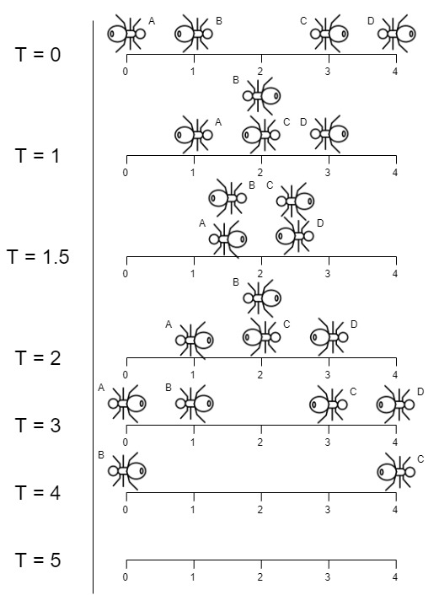

**Input:** n = 4, left = [4,3], right = [0,1]

**Output:** 4

**Explanation:** In the image above:

-The ant at index 0 is named A and going to the right.

-The ant at index 1 is named B and going to the right.

-The ant at index 3 is named C and going to the left.

-The ant at index 4 is named D and going to the left.

Note that the last moment when an ant was on the plank is t = 4 second, after that it falls imediately out of the plank. (i.e. We can say that at t = 4.0000000001, there is no ants on the plank).

**Example 2:**

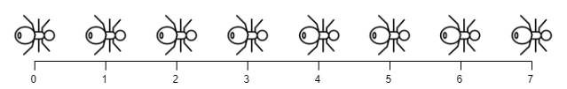

**Input:** n = 7, left = [], right = [0,1,2,3,4,5,6,7]

**Output:** 7

**Explanation:** All ants are going to the right, the ant at index 0 needs 7 seconds to fall.

**Example 3:**

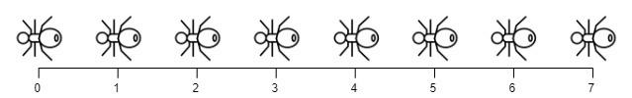

**Input:** n = 7, left = [0,1,2,3,4,5,6,7], right = []

**Output:** 7

**Explanation:** All ants are going to the left, the ant at index 7 needs 7 seconds to fall.

**Example 4:**

**Input:** n = 9, left = [5], right = [4]

**Output:** 5

**Explanation:** At t = 1 second, both ants will be at the same intial position but with different direction.

**Example 5:**

**Input:** n = 6, left = [6], right = [0]

**Output:** 6

**Constraints:**

* 1 <= n <= 10^4
* 0 <= left.length <= n + 1
* 0 <= left[i] <= n
* 0 <= right.length <= n + 1
* 0 <= right[i] <= n
* 1 <= left.length + right.length <= n + 1
* All values of left and right are unique, and each value can appear **only in one** of the two arrays.